India's Agricultural Crop Production Analysis
Team ID : SWTID-2026-5158 PROJECT FINAL REPORT DATE : 7 July 2026

INTRODUCTION :
  - Project Overview :

Agriculture is the backbone of India's economy and plays a vital role in ensuring food security and supporting the livelihoods of millions of farmers. However, agricultural productivity varies significantly across different states due to factors such as crop selection, cultivated area, seasonal conditions, and regional farming practices. Making informed decisions based on these factors is essential for increasing crop production, improving farmer income, and promoting sustainable agriculture.

The **India Agriculture Crop Analysis** project is designed to provide meaningful insights into agricultural performance across various states and crops in India. By utilizing agricultural data such as cultivated area, production, crop type, season, and year, the project helps identify production trends, compare state-wise performance, and evaluate agricultural yield.

The Tableau dashboard enables farmers, policymakers, agricultural officers, and researchers to understand regional agricultural patterns, select suitable crops for different seasons, optimize land utilization, and support effective agricultural planning. The project contributes to improving productivity, strengthening food security, and encouraging data-driven decision-making for sustainable agricultural development.

  - Purpose :

The purpose of the **India Agriculture Crop Analysis** project is to support better agricultural decision-making by providing clear insights into crop cultivation, production, and yield across different states and seasons of India.

The project aims to:

* Improve agricultural productivity by identifying high-performing crops and regions.

- Support farmers in selecting suitable crops based on seasonal and state-wise agricultural performance.
- Strengthen food security through better crop production planning.
- Assist policymakers and agricultural officers in developing effective agricultural policies and resource allocation strategies.
- Promote sustainable farming practices through efficient land utilization and crop planning.
- Help researchers understand agricultural trends for future planning and development.
- Enhance farmer income by encouraging informed decisions based on agricultural performance and yield.

This project serves as a practical decision-support system that transforms agricultural information into actionable insights, enabling stakeholders to improve farming outcomes and contribute to the sustainable growth of India's agricultural sector.

IDEATION PHASE :
  - Problem Statement :

Customer Problem Statement Template:
Create a problem statement to understand your customer's point of view. The Customer Problem Statement template helps you focus on what matters to create experiences people will love.
This customer problem statement aligns well with an Indian Agriculture Crop Production Analysis project and can be used as the problem definition before proposing solutions such as, yield prediction, weather forecasting, disease detection, or market price prediction.

lam

I am an Indian farmer who wants to improve crop productivity and make better farming decisions.

I am an agricultural officer who supports farmers with crop planning and agricultural development.

I'm trying to

I am trying to choose the most suitable crops for different seasons and make efficient use of my agricultural land to increase production and income.

I am trying to recommend suitable crops and improve agricultural productivity in different regions.I

But

But I do not have easy access to clear, organized information about crop cultivation, production, yield trends, and regional agricultural patterns.

But I find it difficult to compare crop production, cultivated area, and yield

across states and seasons efficiently.

Because

►
Because agricultural data is scattered, complex, and difficult to analyze, making it challenging to compare crop performance across states and seasons.

►

Because the available agricultural data is extensive and not easy to interpret without proper visualization.

Which makes me feel

Which makes me feel uncertain and less confident in making farming decisions, affecting productivity,
- profitability, and long-term sustainability.

Which makes me feel limited in providing timely
and data-driven recommendations.

  - Empathy Map Canvas :

Empathy Map Canvas:

An empathy map is a simple, easy-to-digest visual that captures knowledge about a user’s behaviours and attitudes.

These features help farmers make informed decisions, improve productivity, reduce risks, and increase profitability.

It is a useful tool to helps teams better understand their users.
Creating an effective solution requires understanding the true problem and the person who is experiencing it. The exercise of creating the map helps participants consider things from the user’s perspective along with his or her goals and challenges.

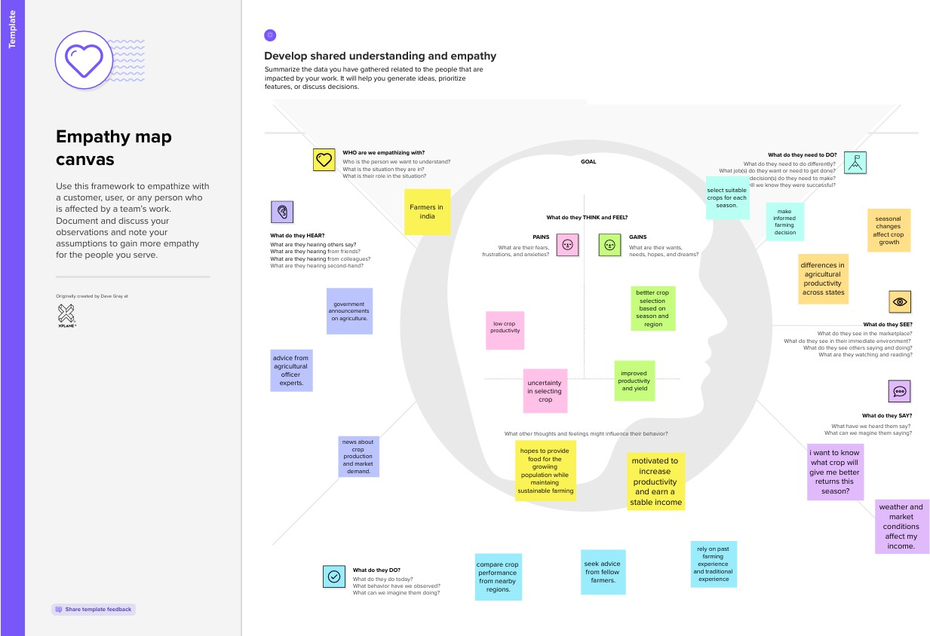

  - Brainstorming :

Brainstorm & Idea Prioritization Template:
Brainstorming provides a free and open environment that encourages everyone within a team to participate in the creative thinking process that leads to problem solving. Prioritizing volume over value, out-of-the-box ideas are welcome and built upon, and all participants are encouraged to collaborate, helping each other develop a rich amount of creative solutions.
Use this template in your own brainstorming sessions so your team can unleash their imagination and start shaping concepts even if you're not sitting in the same room.



B1rainstorm
& idea prioliiitization
u... ht. l""l)'lol<I"' 1"""""
lbr.lln&1i!rmhg :i:�lons: :i:o'/CA.r lii::un
an 1..11b.kiih lha.-lr lm...1glootloo .v-.:1
•t.111 ""Ph;! o:.n<»,pt• WQl1 ya.tr,;,
imx s; .. hg .-. hlil � roan.

r!i'"li:l,N'&JKII�
liil:1Mi.i'll_,...i
&:11a1,.1�111:a-
•Balorvi yot.i c..all'ilbor.::1ta
,\ l•bl alpap.11,1hn 1ijpi111 ■ IW11 �
Mt, INl.-lm"I.IN1•"1.'M'III � .._.d
ic-.:fa l-:-1j1111l g,:i1q
Cttc-r.illi'IHI

-.-..
----•-t-111t,ai'lo..oil .. --- .........

.. --■-.-.-.--�·--

..!J ............
u.•-..LW-�,.....- ...........-- ...........

[!J ....,.._••._ . ._
UM,U.,........::.,.■�,-. ....i.:.,.,,1�.-.:11
�.-1-111-.
•DuNrlD �oor rprolllilm S.1llftll1KIM
'Mui i:n:t:a.n ll•'l'CN 11)1"11 ic.llD'II rrvHyall
pteibllft -.. MIMNritRW..UllNrHrJ. n..11. btl U.
ma8eil:ia,rl:ra"ll'D'TTI.

it!••···-

.-.._;1.1...-.................._. ..
.....rii ...La,n....
..lllil,alilllf--.1
·-•lfll:rl'

eCIHilil....,...... I 1.li,I.,. w..w.•.i ..



•er•rto.rm
..-.;.dcanani,kiultha:crn•m,.h:I
liv11-..•y,:11;1"p,tc.lNl,1-


�....,............-........�...
,..............

�.........,._.,...,.,
..,...........-............d...£...1,.....
0
G1oupli:kt.1s
tai..i......,_..11't<'u1---....,t.1o,DJ.....,g...,.•1111.t.-.:l"noOM•VD.11P-Onal•I
ndc'f11&11.•M,ii11IMffl� 11,.._•1cr.d.l-■-�llltMlr■CUJHII
�gwh11u1bc�ra" ty•nd-11·, 1r,dbi..i,;:1..,1nio-.,.1..,1ib-g-aupa

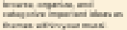

in.:r�11 :.gra:uNur.11Prodllellon
·--
- ,,,,
\T1p-c�11!_,.,.,. 1
n:DT1•t:r1 unc..-n.-dn:;i ct:pFOrl.>c:%'i.y
-,=111t111cnll
119t1:rn1nc•

l;sl'Uu·•�I
1ru,rci1d:...-.
:o::p::�il•n:-n
�U:2-:»1.■rd,.K: 11..-.d,
, .
H.
i,....
._,,
...
_ .
-
. ,..
., .......... .....
.
.........
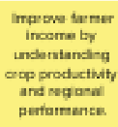
Suitable Crop Selection
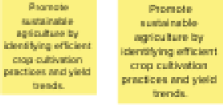

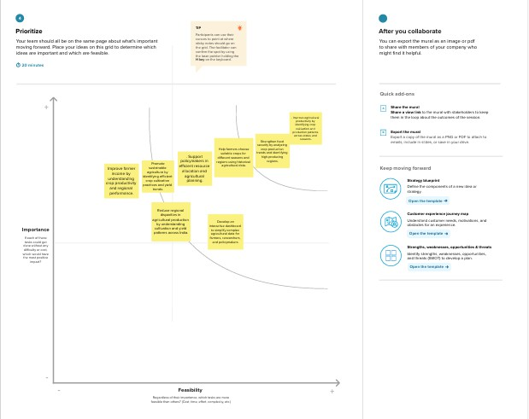

REQUIREMENT ANALYSIS

  - Customer Journey map :

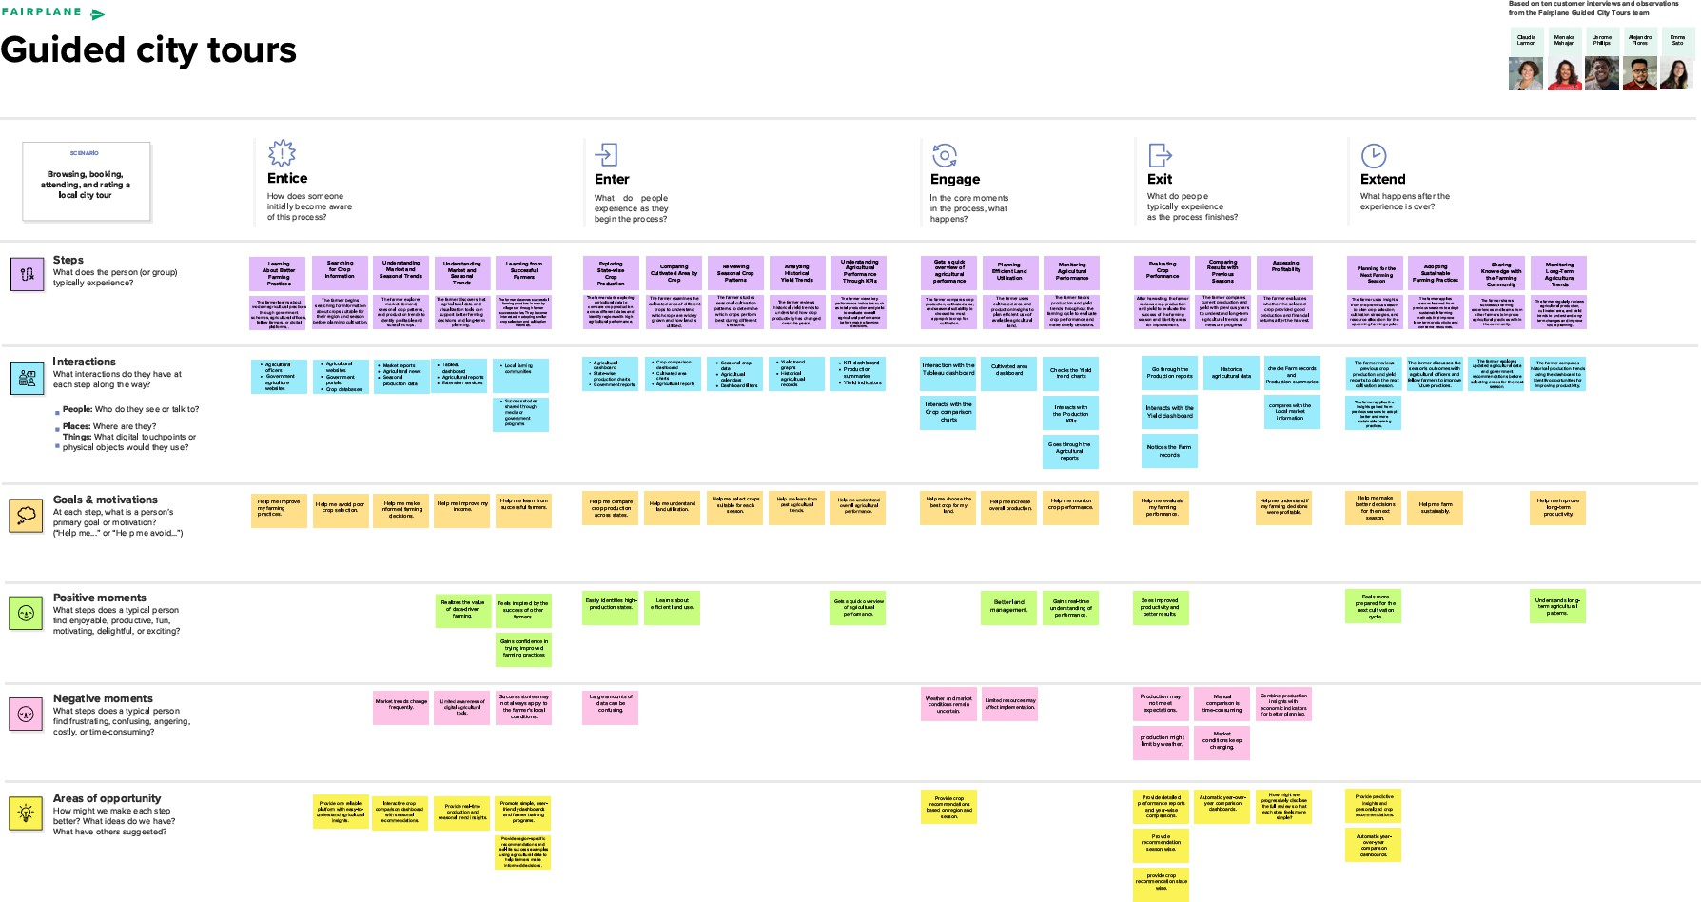

  - Solution Requirement :

Functional Requirements:

Functional Requirements:
Following are the functional requirements of the proposed solution.
FR No. | Functional Requirement (Epic) | Sub Requirement (Story / Sub-Task)
FR-1 | Agricultural Data Visualization | Display state-wise cultivated area comparison. Display crop-wise cultivated area.
FR-2 | Production Analysis | Display state-wise agricultural production. Compare production across states and crops.
FR-3 | Yield Analysis | Show year-wise agricultural yield trends. Analyze historical yield data.
FR-4 | Dashboard KPIs | Display Total Production KPI. Display Total Yield KPI.

FR-5 | Data Filtering | Filter data by State.Filter data by Crop Filter data by Season.  Filter data by Year.
FR-6 | Reporting & Insights | Generate interactive visualizations. Provide summary insights for stakeholders.

NFR No. | Functional Requirement (Epic | Sub Requirement (Story / Sub-Task) Sub Requirement (Story / Sub-Task)
NFR-1 | Usability | The dashboard should be easy to navigate and understand for farmers and stakeholders.
NFR-2 | Performance | Dashboard should load charts and KPIs quickly with minimal delay.
NFR-3 | minimal delay. | Display accurate and consistent agricultural data.
NFR-4 | Availability | .Dashboard should be accessible whenever users need agricultural insights.
NFR-5 | Scalability | Support additional datasets such as weather, market prices, and district-level data in the future.
NFR-6 | Security | Ensure agricultural data is securely stored and protected from unauthorized modifications

  - Data Flow Diagram :

Data Flow Diagrams:
A Data Flow Diagram (DFD) is a traditional visual representation of the information flows within a system. A neat and clear DFD can depict the right amount of the system requirement graphically. It shows how data enters and leaves the system, what changes the information, and where data is stored.

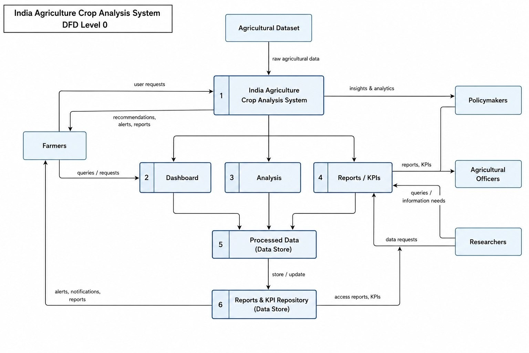
User Stories
Use the below template to list all the user stories for the product.
User Type | Functional Requirement (Epic) | User Story Numbe r | User Story / Task | Acceptance criteria | Priority | Release
Farmer | Dashboard Access | USN-1 | As a farmer, I want to view state-wise cultivated areas so that I can understand agricultural land distribution. | The dashboard displays cultivated areas for all states. | High | Sprint-1
Farmer | Crop Analysis | USN-2 | As a farmer, I want to compare cultivated areas of different crops so that I can select suitable crops. | Crop-wise cultivated area visualization is available. | High | Sprint-1
Farmer | Yield Trend | USN-3 | As a farmer, I want to analyze agricultural yield trends over the years so that I can improve future crop planning. | Year-wise yield trend graph is available. | Medium | Sprint-2

Farmer | Dashboard Summary | USN-4 | As a farmer, I want to view total production and yield KPIs so that I can quickly evaluate agricultural performance. | KPI cards display total production and yield. | High | Sprint-1
Farmer | Production analysis | USN-5 | As a farmer, I want to view state-wise agricultural production so that I can identify  high-performing regions. | State-wise production dashboard is displayed. | High | Sprint-1
Policymaker | Production analysis | USN-6 | As a policymaker, I want to analyze agricultural production across different states so that I can allocate resources effectively. | Acceptance Criteria State-wise comparison dashboard is available. | High | Sprint-2
Agricultural Officer | Yield Trend | USN-7 | As an agricultural officer, I want to identify crop production trends so that I can provide better recommendations to farmers. | Crop-wise and season-wise analysis is available. | Medium | Sprint-2

  - Technology Stack Technical Architecture:
The Deliverable shall include the architectural diagram as below and the information as per the table1 & table 2

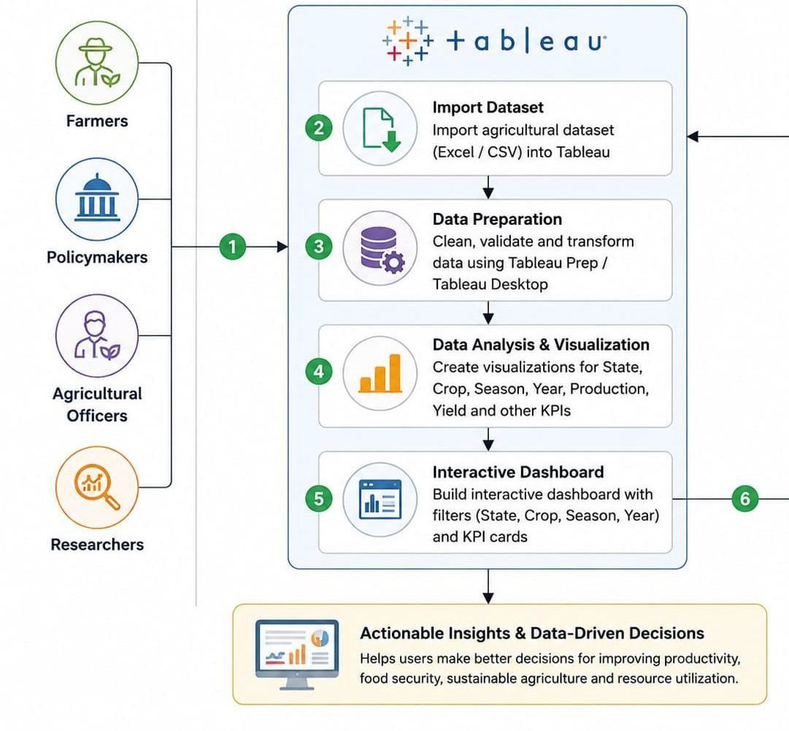

S.No | Component | Description | Technology
1. | User Interface | Interactive dashboard for agricultural data analysis . | Tableau Dashboard

2. | Application Logic-1 | Data preparation and transformation | Tableau Prep / Tableau Desktop
3. | Application Logic-2 | Data visualization and dashboard creation | Tableau Desktop
4. | Application Logic-3 | Interactive filters, KPIs and charts | Tableau Calculated Fields & Dashboard Actions
5. | Database | Agricultural dataset storage | Excel (.xlsx/.csv)
6. | Cloud Database | Not used | N/A .
7. | File Storage | Store dataset and Tableau workbook | Local File System
8. | External API-1 | Not used | N/A
9. | External API-2 | Not used | N/A

10. | Machine Learning Model | Not used | N/A
11. | Infrastructure (Server / Cloud) | Local system used for Tableau development | Windows PC + Tableau Desktop

Table-2: Application Characteristics:
S.No | Characteristics | Description | Technology
1. | Open-Source Frameworks | Data processed using CSV/Excel datasets | CSV / Microsoft Excel
2. | Security Implementations | Local file access and Tableau workbook protection | Windows User Authenticatio n
3. | Scalable Architecture | Dashboard can be extended with additional datasets like weather, market prices, district-wise analysis | Tableau Dashboard Architecture
4. | Availability | Dashboard is available on the local system and can be published to Tableau Public if required | Tableau Desktop / Tableau Public

S.No | Characteristics | Description | Technology
5. | Performance | Optimized dashboard with filters, KPIs and interactive charts for fast analysis | Tableau Desktop

PROJECT DESIGN

  - Problem Solution Fit :

Problem – Solution Fit Template:
The Problem-Solution Fit simply means that you have found a problem with your customer and that the solution you have realized for it actually solves the customer’s problem. It helps entrepreneurs, marketers and corporate innovators identify behavioral patterns and recognize what would work and why
Purpose:
    - Solve complex problems in a way that fits the state of your customers.
    - Succeed faster and increase your solution adoption by tapping into existing mediums and channels of behavior.
    - Sharpen your communication and marketing strategy with the right triggers and messaging.
    - Increase touch-points with your company by finding the right
problem-behavior fit and building trust by solving frequent annoyances, or urgent or costly problems.
    - Understand the existing situation in order to improve it for your target
group.

Template:

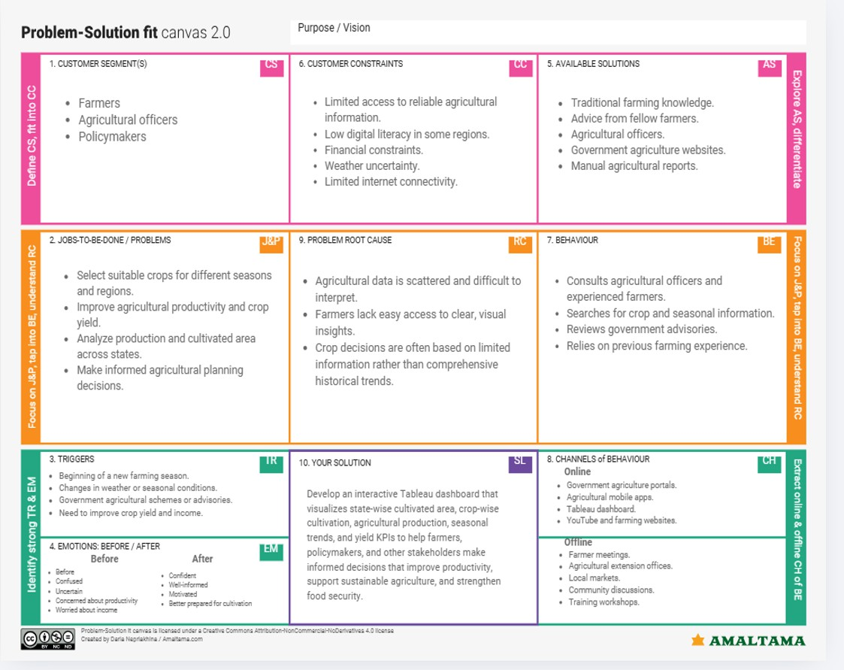

  - Proposed Solution :

Proposed Solution Template:

Proposed Solution Template:

S.No. | Parameter | Description

1. | Problem Statement (Problem to be solved) | Farmers and agricultural stakeholders struggle to make informed decisions due to poor understanding of crop cultivation, seasonal trends, production, and yield.  This can affect agricultural  productivity, food security, and efficient resource utilization.
2. | Idea / Solution description | Create an interactive Tableau dashboard that uses state-by-state cultivated area, crop-by-crop cultivation, agricultural production, seasonal trends, yield analysis, and KPIs to analyse agricultural data in India. Farmers, legislators, and researchers may make data-driven decisions with the dashboard's clear visual insights.

3. | Novelty / Uniqueness | Provides easy-to-understand visualizations for quick analysis. Supports comparison across states, crops, and years for better planning.

4. | Social Impact / Customer Satisfaction | Improves agricultural productivity through informed decision-making.  Supports food security by helping identify high-performing crops and regions Helps policymakers develop better agricultural strategies and resource allocation.
5. | Business Model (Revenue Model | The dashboard can be offered as a subscription-based analytics platform for government agencies, agricultural organizations, agribusinesses, and research institutions. Basic insights can be provided free of cost to farmers, while advanced analytics and customized reports can be available through premium plans
6. | Scalability of the Solution | Can be expanded to include  real-time weather data and market prices.  Can be integrated with mobile applications for wider farmer access.  Can incorporate AI-based crop recommendations and yield prediction in the future

  - Solution Architecture :

Solution Architecture:

Solution architecture is a complex process – with many sub-processes – that bridges the gap between business problems and technology solutions. Its goals are to:

- Find the best tech solution to solve existing business problems.
- Describe the structure, characteristics, behavior, and other aspects of the software to project stakeholders.
- Define features, development phases, and solution requirements.
- Provide specifications according to which the solution is defined, managed, and delivered.

Solution Architecture Diagram:

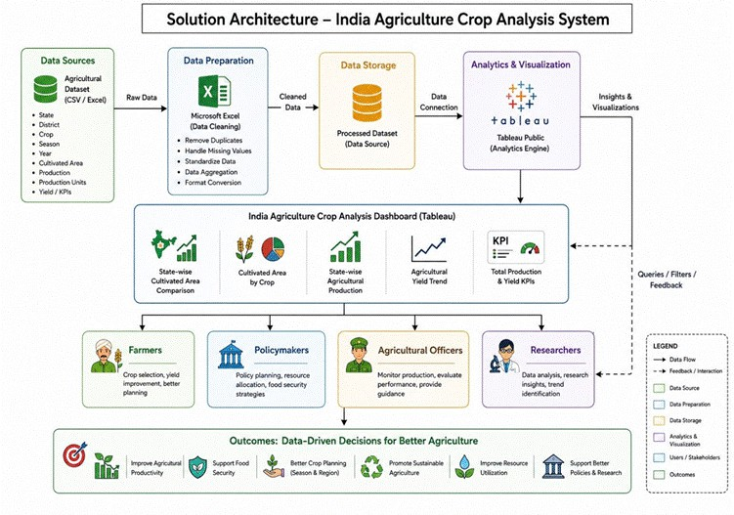

PROJECT PLANNING & SCHEDULING

  - Project Planning :

Product Backlog, Sprint Schedule, and Estimation (4 Marks)

Sprint | Functional Requirement (Epic) | User Story Number | User Story / Task | Story Points | Priority | Team Memb ers
Sprint-1 | Project Templates | USN-1 | Ideation Phase, Empathy Map, Customer Journey Map, Requirement Analysis, Project Design. | 5 | High | Chanch al Sehgal & Kumku m Jangid

Sprint-2 | Data collection | USN-2 | Collect agricultural dataset containing state, district, crop, season, year, area, production and yield | 2 | High | Kumku m Jangid
Sprint-2 | Data integration | USN-3 | Import the dataset into Tableau | 2 | High | Chanch al Sehgal
Sprint-2 | Data preparation | USN- | Clean, preprocess and validate the agricultural dataset for analysis. | 3 | High | Munisa Zehra
Sprint-3 | Data visualisation | USN-5 | Create state-wise cultivated area and crop-wise cultivated area visualizations | 5 | High | Munisa Zehra
Sprint-3 | Dashboard development | USN-6 | Develop production analysis, yield trend charts and KPI cards. | 5 | High | Munisa Zehra
Sprint-3 | Dashboard features | USN-7 | Add interactive filters for State, Crop, Season and Year. | 3 | Medium | Kumku m Jangid
Sprint-4 | Performance testing | USN-8 | Test dashboard functionality, accuracy and usability. | 3 | High | Hansika Choudh ary
Sprint-4 | Project Documentation | USN-9 | Prepare project presentation, documentation and final demonstration. | 2 | High | Hansika Choudh ary
Sprint-4 | Project Demonstration | USN-10 | Final demonstration of the project | 3 | High | Munisa Zehra

Project Tracker, Velocity & Burndown Chart: (4 Marks)

Sprint | Total Story Points | Durati on | Sprint Start Date | Sprint End Date (Planned) | Story Points Completed (as on Planned End Date) | Sprint Release Date  (Actual)
Sprint-1 | 5 | 2 Day | 01 July 2026 | 02July 2026 | 5 | 03 July 2026
Sprint-2 | 7 | 1  Days | 03 July 2026 | 03 July 2026 | 7 | 03 July 2026

Sprint-3 | 13 | 2  Days | 04 July 2026 | 05 July 2026 | 13 | 05 July 2026
Sprint-4 | 8 | 2  Days | 05 July 2026 | 06 July 2026 | 8 | 06 July 2026

Average Velocity :
- Total story points = 33
- Velocity of team or total number of days
Average Velocity = Total Story Points / Velocity

= 4.7 story points/day

Burndown Chart:
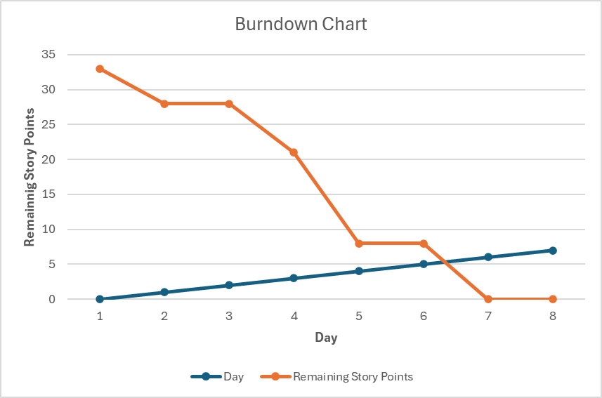

FUNCTIONAL AND PERFORMANCE TESTING

  - Performance Testing :

S.No. | Paramet  er | Screenshot / Values
1. | Data Rendere d | Dataset successfully connected and rendered in Tableau. Dataset contains 345,408 rows and 10 columns covering agricultural production data from 1997–2021.  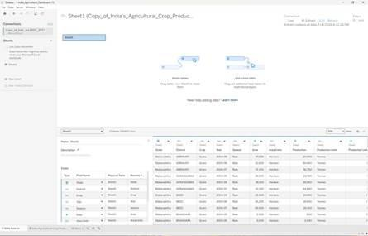
2. | Data Preproc essing | Connected dataset to Tableau, verified data types, organized dimensions and measures, and created a calculated field named Production Efficiency (SUM([Production]) / SUM([Area]))  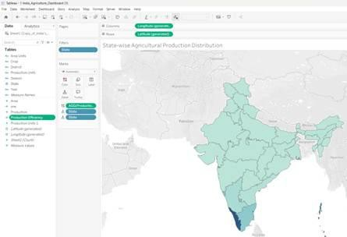

3. | Utilizati on of Filters | Implemented interactive dashboard filters: State Filter, Crop Filter, and Production Range Filter. Applied filters to all worksheets using  the same data source. 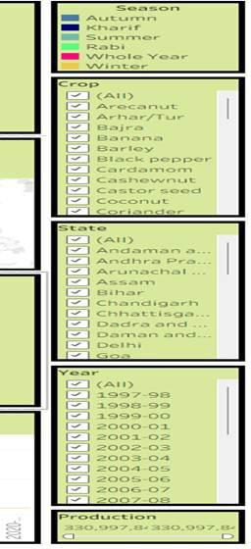
4. | Calculat ion fields Used | Production Efficiency = SUM([Production]) / SUM([Area])

5. | Dashbo ard design | No of Visualizations / Graphs – They are:  - KPI – Total Production  - KPI – Total Yield  - Agricultural Yield Trend (Line Chart)  - India Production Map  - Crop-wise Total Production Analysis (Horizontal Bar Chart)  - State-wise Cultivated Area Comparison (Grouped Bar Chart)  - Leading States by Agricultural Production (Bar Chart)  - Year-wise Total Agricultural Production (Bar Chart)  - Production Distribution by Unit Type (Donut Chart)  - Season-wise Agricultural Production Share (Pie Chart)  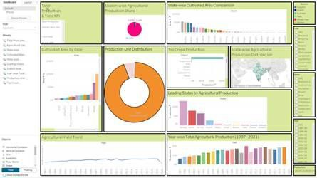
6 | Story Design | No of Visualizations / Graphs –  - India Agriculture Overview  - Geographic Distribution  - Crop and State Performance Analysis  - Seasonal Production Patterns  - Agricultural Growth Trends (1997–2021)

RESULTS

  - Output Screenshots

Visualization

l lndiaJiiricutwn1_0ashboard by mun&ll zehra
Season-wise Agricultural Production Share
State-wise CultimtedArea CompmUOII

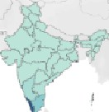

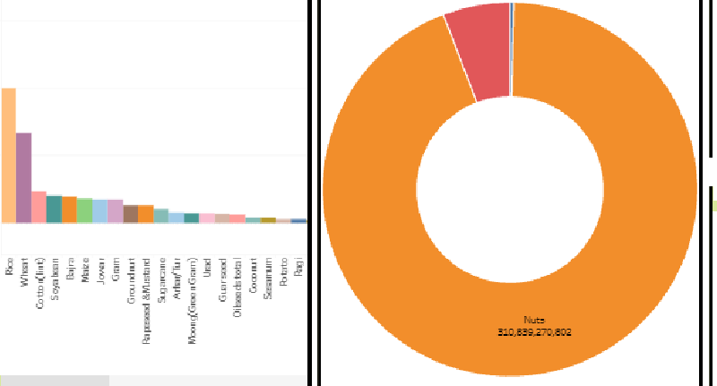
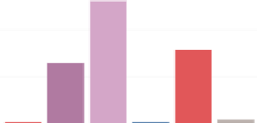
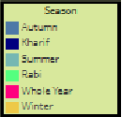
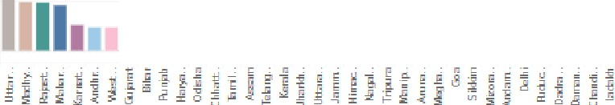
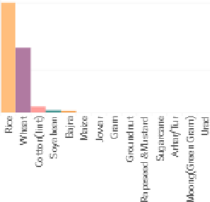
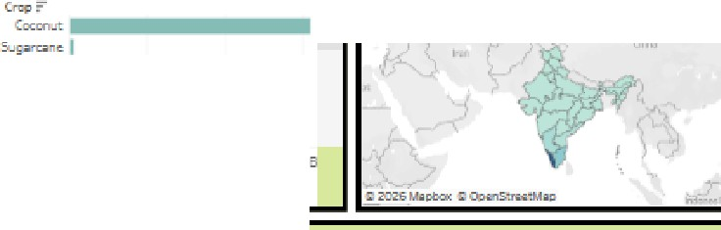
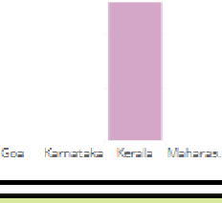
{!::,Vicwc,nl;,1::d�Puclic.
-,
,.1
(
2l1�
Agricultural Yield Trend
Year-wlseTocalAgriculturalProduction(l997-2021)
i:. 1 111Ill
I I Ill I
I
(2l;:oo;:-s'.l?
0=
@;:004-05
0=�
@;:w.,-0;
Gl=•«
0•=
(11=:.o
0 2001-{;2
0�•
Total ProdK:tion &YfeldKPI
:=cu:ttiV=at=ed=Ar=na=by=cr=op===::::::::=:Pro=du=ctiO=II U=ni=tDi=ffb:=ibu=ti0=11=::::::::=:=To=p=Cro=ps=Pr=od=oc=t1o=n =::::;-;:::::S:tat:e-:wis:e:Ag:nc=ult=ur=al P=ro=du=ct=ion=rn=stn=b=uti:on�::1:21 c;aroa,nor�,
•
i1i11iIrj i !�f �ilj1 i
......
1
1
1
-- ---
1
11
1j Ji�i1lii
'0",:'AJIJ
8
G:):..rc"""'
;;-:�
(2lc..,.; ,,
G:Jc.,,,,. ,=1
Gl=
Gl=•-
,$,�..,r.t,-�
�Go.,pe•J<"-
0�1-.J
Gl='"�"-
0,:,11
0c,.,�.0r�
=:===========!:"=•==-=•===-=======�='.:'.:�:"":-:
ding Sta
tes. by A_gricult
unL
!Pro
duc
tion
G:l=m,
[2lc ,._,-;am
0a- ,,�.,,,
11lJ•-··•rd-
0,.,. "
0�
0�,
:=:==========�==========:=:�======================:::::::�=
I'...,
Gj1'E7-9'6
rdiaA;ric.,l':.111:
""=•
S-..=.0ra:,-::
).:,'.!'b-::;rd
Ci.9an:!'.:t.-:,e
Su:on--v.:,: :.,;ir�•.za Gn, �
:�r-:.i:.'ra,-::, :ro:iu-=crP=-:r-r: -,..._-d:,:�:'-2D.Zl.;
Top Crops Production
State-wiseAgricultural Productiora Distributiora
Leading States by A_griculrural Production
, ,,.d,a
=-d'-l'a,_ ;:lr.d,,,h
-■ _I_
Agncul:ural Yield Trend
Year-\1.,"i� Total.Agricultural Production(l997-2021)

,re
'=
0'.-"�
0�7..-;;a
0i.;-;t-,:;.;
0L OO
0=
02001-02
02002-03
G:)Z0:::3-0'!
0zoc os
0 ZOE-05
0'°"'"'
-�-�-�-�-�---�-�-·-�-�-· -�-�-�-�-�-·-�-�--�-- -�-�--�-�-- �� ;_!�i s ---"�8-8��-��----; -� l�I
i:. 1111Ill
0(.(.,•r.:
0(;.J!)
India Agriculture Overview
0(-"Jt
0: :.a.-a-ar.....
0" ?i-ad..
(Zl.>r.inad,;JPr...
(Zl.>..�:r-
Production Unit Distribution
Cultivated Area by Crop
0.,.-:::...-..r.:
0°r:r/11
0&,r.
(Zl:t=-::.:
03.::rtr;
05:adp:,pp:r
G:)Ca,,:anc,-,
0C:�1•r.i.r.:
G:)c.,,_,._�
@C::-=n.":
0""",,,_,
'-=�
iG-ad
- '=-=
I■•••• -- -- --
State-v.'ise Cultivate.dArea CompMiwn
Season-wis.eAgricultural Production Share
Total Pra&Jction & YieldKPI
:
Lea.
I I I I I I
0SJ-:,
00-.-:,..,...
0o-t-a:-:::;aM
0.'.);:J:l"::r.dN
0.::i.,-,ar:nd G:)AI�,

India Agciculture Overview

rdi■.:.-f..·=uttur� O.cer.-�,�
<
Sta?!_:. ,;J:,��1
D.::• b,:r.:i
Crq:, .ard St.oe
=�rri:ir,:� .:. '"ii y��
Sea�a,...,.,. �
=ro=L::::r: :Jr P.mel'r!!!
..:..gria.:-:_r,; ::;ro-.-.'t�
- _..12 (::s;:1-.:m2"1)
>

5■t:,t.<,  0n:i:;i:: .a d Nioob:• ,l:n:i,  - 0n:ihr: "r.aceh  - G,:  .-(:,.,.-t;",::  - r. iiif"riiilntrriiil  ■-:r,il -LI  ;•Pr:&.,,  - �. �d;"'"'�� |  | Lea.ding States by Ag:ricfililtuca!l. Production  .l! 1003  J�  503  D3  - jJ 11 r. ..Ii r. j11 �  ..Eaif"i � J el � '§ � i    � ] ::,: � c9  ::,:- Ci. E .Ei ,=;: Ci.  'E ,!l :§ � i  "
State-wise AgriculturaI Prodl..lCT i ori Distribution

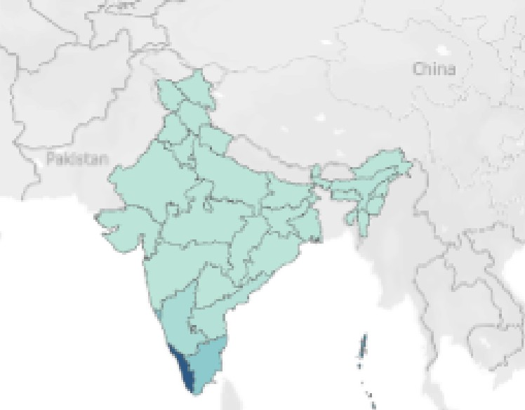

� 2112& M'l']ba>: � llp,;nStrootil.lO!!J
State-"vise CultnratedArea Compaiiron

1000

••
� 500 lb
-=I
cl I I ••
]]]j ..Ii! - ..... -= r.l r:l -E i C- r, r,
�GJ.��=ij = '§
JJ .,d ll iiE a.Cl, -⁼ .;: -.ll 'D B "' ] ��
E o 'fi 1: .ll
� � ill .E ,;l " - ;II
jj -= :§ :§ �
u
::, �

India Agriculture Overview

rd"ii .:.--£r"1lltur�
<
o.�r.-�,�
St.�..:.n,;;; :,��
:l.a�-b,ard
Crop .ar St.oe
t;:er-:lrr,.;;rc�..:.=.. -�
Se;eon_.,.,. �
=ro:L:z Jr P.-tr:err�

..:..gria.:-:_riiil �ro.-.'1:�
-.-e...-cl!i :::.9�7-1Dl"1J
>

5t;_':,o
- •
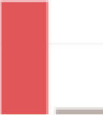
crd.n.r ;; _ N"ccf.:,.r L .; do 'crd�r,=a r.dee�
Leading States by Ayiccltmal Produ:ction
C :ira:JB
0
-�
,:,
£
9:JB
OB
<{ � il
!�
]
_I
�"
�
"""fj r. - ..�
E
,!l
,1j
� �2
�
r, Tl
::, �
t:1.51
ec
Ii
c9
- ��"\iiln
Go.a
- K..rr<lt;;k.
1(..,-,al-
■■
r. -��r.ehr;;
T..nilN.d
U":---ir Flr,;;c.e:�
W•..tw:3.I
■·"'"�""ut
.:. �,-ur
■
Crop
3-jr. 3== ii 3-rl!OJ
■
■
5,;c'kp�H,�r
:ard;;r:,c.-:,
::.�he-.urut
- :..
tar,-:!
■:cc "�
■
::ori.rd�r
:cctcn( ire)
■
::o- �r..o::ii-J
-:m1 ilr.,,
■
-:m1:;;n;,.,

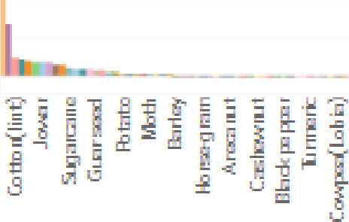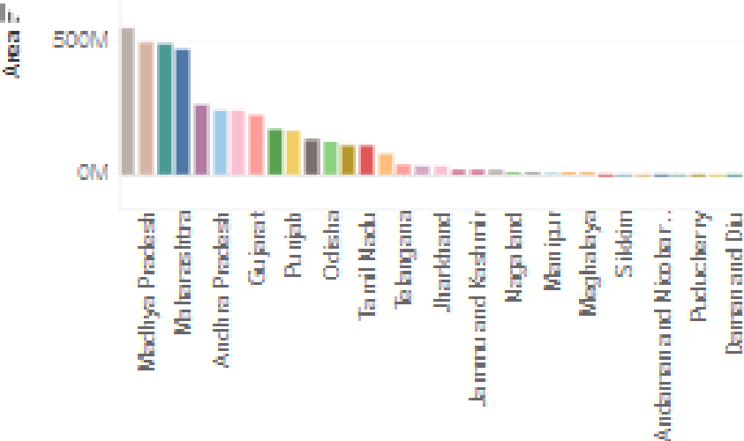
Cultivated Are.aby Crop
Cro,p
L5B
1.B C.5B GB
State-Vlise GuJti,.-ated Acea GompMiwn

1COCM

India Agrirulture Overview


St;�..:.n,;;; :,,�?!
::.i�-bJ;;;;rd
Crca,;ird5tiiii� Se;;;;eai--.-.'1�
:er-=arr,.;ir,:_�:. -- )�� i;:rn _·,Jr P...-tter.e
..:..gria.-:_r,;;i:::;ro-.-.r:�
- _-12i :::.g�i::•-.:rn.21)
)

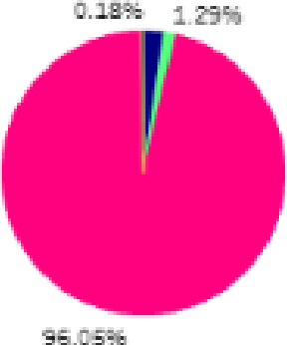
  - ,s.u1:1..rr,,
Season-wise Agricultural roduction Share
  - <:hari-
  - s rier
  - �-o _ ..,.,,_,
Wir,er

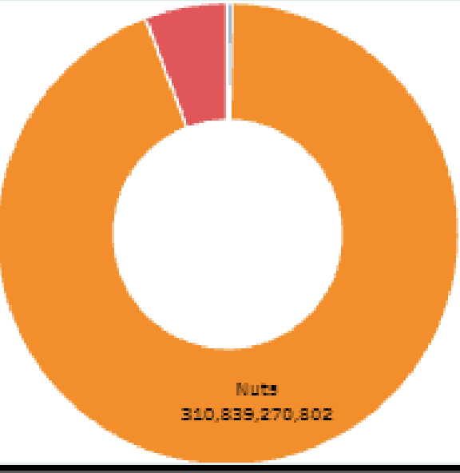
Production Unit Distribution

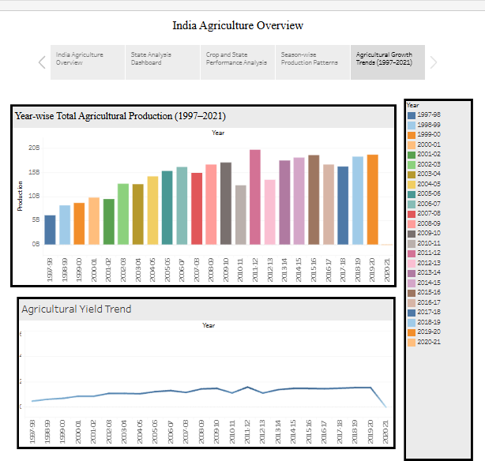

Here Is a Tableau Public Link :
https://public.tableau.com/views/1India_Agriculture_Dashboard/IndiaAgricultural CropProductionAnalysis19972021?:language=en-GB&:sid=&:redirect=auth&:displ ay_count=n&:origin=viz_share_link

ADVANTAGES & DISADVANTAGES

Advantages
- Provides state-wise insights into cultivated area, production, and crop yield to support better agricultural planning.
- Helps farmers choose suitable crops based on seasonal and regional agricultural performance.
- Assists policymakers in identifying high-performing and low-performing agricultural regions for effective resource allocation.
- Supports sustainable farming by encouraging efficient land utilization and improved crop selection.
- Strengthens food security by highlighting production trends and helping improve agricultural productivity.
- Enables agricultural officers and researchers to monitor crop performance and identify long-term agricultural patterns.
- Presents agricultural information in a simple and easy-to-understand format, making decision-making more effective for different stakeholders.

Disadvantages
- The accuracy of recommendations depends on the quality and completeness of the available agricultural data.
- The project does not consider external factors such as weather conditions, soil quality, irrigation facilities, pest attacks, and market prices.
- Historical agricultural data may not fully represent current farming conditions or future climate changes.
- Results are limited to the crops, states, and years available in the dataset.
- Farmers still need local agricultural guidance before making final cultivation decisions.

CONCLUSION

The India Agriculture Crop Analysis project focuses on addressing key agricultural challenges by providing meaningful insights into crop cultivation, production, and yield across different states and seasons. The project supports farmers in selecting suitable crops, helps policymakers make informed

agricultural planning decisions, and assists researchers in understanding regional agricultural performance.
By identifying cultivation patterns, comparing state-wise production, and evaluating agricultural yield, the project contributes to improving agricultural productivity, strengthening food security, and promoting sustainable farming practices. It encourages evidence-based decision-making that can lead to better resource utilization, higher farmer income, and long-term agricultural development.
Overall, this project serves as a practical decision-support solution that benefits multiple stakeholders and contributes to the sustainable growth of India's agricultural sector.

FUTURE SCOPE

The project can be further enhanced by incorporating additional agricultural and environmental information to provide more comprehensive decision support.
Future improvements include:

- Integrating real-time weather forecasts to improve seasonal crop planning.
- Including soil health and fertility data for more accurate crop recommendations.
- Adding irrigation and water availability information to support efficient resource management.
- Incorporating market price trends to help farmers maximize profitability.
- Using machine learning techniques to predict future crop yield and production more accurately.
- Developing district-level and village-level agricultural recommendations for localized decision-making.
- Providing mobile-based access so farmers can easily obtain agricultural insights and recommendations.
- Integrating government agricultural schemes and subsidy information to support farmers in accessing available benefits.
These enhancements can further improve agricultural productivity, promote sustainable farming, strengthen food security, and support informed
decision-making for farmers, policymakers, agricultural officers, and researchers.

APPENDIX

Dataset Link :

https://docs.google.com/spreadsheets/d/1SLqjCAhYMldwNg f2sZfVty8vz84mnM
/edit?usp=sharing&ouid=118218726975855399976&rtpof=true&sd=true Tableau Public Link :
https://public.tableau.com/views/1India_Agriculture_Dashboard/IndiaAgricultural CropProductionAnalysis19972021?:language=en-GB&:sid=&:redirect=auth&:displ ay_count=n&:origin=viz_share_link

GitHub & Project Demo Link :

GitHub : https://github.com/jkumkum2604-eng/Indian-Agriculture-crop-Analysis-

Project Demo Link : https://drive.google.com/file/d/1sJU7BlWkxdIfyj_xSqkGFRoIGaJ38ZmL/view?usp
=sharing

